SIMATS ENGINEERING
CO- 2: AT – 2: Simulation Task – Medium

COURSE NAME: 5G / 6G Communication Systems
COURSE CODE: ECA5604
SLOT A
STUDENT NAME: V Charan kumar
REG NO: 192312365

Experiment 1: Simulation of LTE throughput performance under varying bandwidth, SNR, modulation order, coding rate, and user load
Objective:
To simulate LTE throughput performance under varying bandwidth, Signal-to-Noise Ratio (SNR), modulation order, coding rate, and user load using MATLAB, and to analyze the effect of these parameters on the overall network throughput.
Procedure:
- Open MATLAB software.
- Create a new script file.
- Enter the LTE throughput simulation MATLAB code.
- Define the input parameters such as bandwidth, SNR, modulation order, coding rate, and user load.
- Calculate the LTE throughput using the defined parameters.
- Display the average values of bandwidth, SNR, modulation order, coding rate, user load, and throughput in the MATLAB Command Window.
- Plot the LTE throughput performance graph using the calculated throughput values.
- Run the program and analyze the effect of bandwidth, SNR, modulation order, coding rate, and user load on LTE throughput.

MATLAB CODE:

clc;
clear;

n = 20; % Number of users

% Input Parameters
bandwidth = 5 + 15*rand(1,n); % Bandwidth (MHz)
snr = 5 + 20*rand(1,n); % SNR (dB)

modOrder = [2 4 6]; % QPSK,16QAM,64QAM
modulation = modOrder(randi(3,1,n));

codingRate = 0.5 + 0.4*rand(1,n); % Coding Rate

userLoad = 10 + 90*rand(1,n); % User Load

% Throughput Calculation
throughput = bandwidth .* log2(1+snr) .* codingRate .* modulation ./ userLoad * 10;

% Display Results
fprintf('Average Bandwidth = %.2f MHz\n',mean(bandwidth));
fprintf('Average SNR = %.2f dB\n',mean(snr));
fprintf('Average Modulation Order = %.2f\n',mean(modulation));
fprintf('Average Coding Rate = %.2f\n',mean(codingRate));
fprintf('Average User Load = %.2f\n',mean(userLoad));
fprintf('Average Throughput = %.2f Mbps\n',mean(throughput));

% Plot Graph
plot(throughput,'b-o','LineWidth',2);
xlabel('User');
ylabel('Throughput (Mbps)');
title('LTE Throughput Performance');
grid on;

OUTPUT:
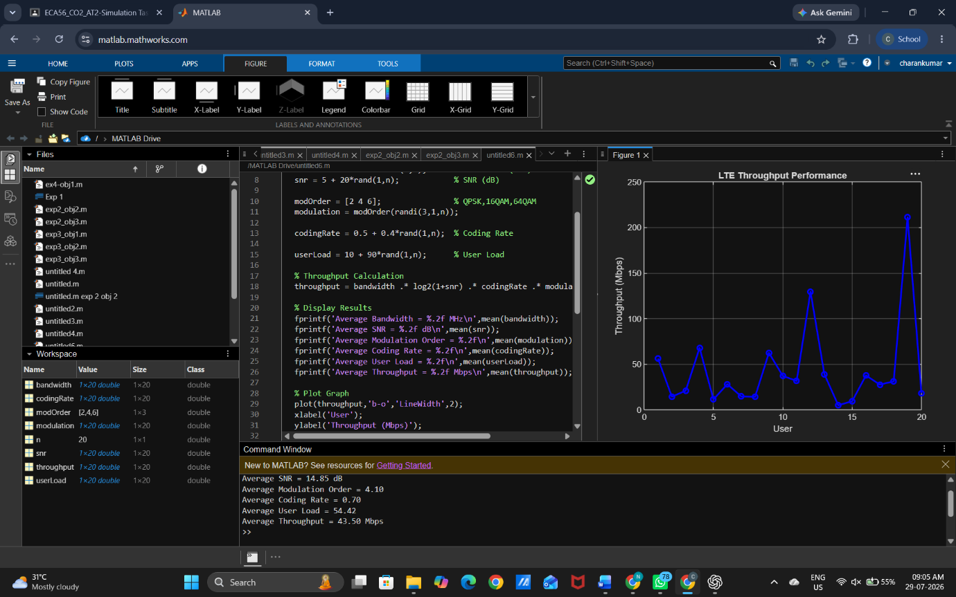

RESULT:
The MATLAB simulation successfully evaluated LTE throughput performance under varying bandwidth, SNR, modulation order, coding rate, and user load. The results showed that higher bandwidth and SNR improved throughput, while increased user load reduced network performance.

Experiment 2: Simulation of LTE Protocol Stack Delay Analysis

Objective:
To simulate LTE protocol stack delay analysis under uplink traffic, downlink traffic, packet size, retransmission count, and channel quality using MATLAB.

Procedure:
- Open MATLAB.
- Create a new script file.
- Enter the LTE protocol stack delay analysis MATLAB code.
- Define the values for uplink traffic, downlink traffic, packet size, retransmission count, and channel quality.
- Calculate the protocol stack delay.
- Display the average values of all parameters.
- Plot the delay graph.
- Run the program and analyze the LTE protocol stack delay performance.

MATLAB CODE
clc;
clear;

n = 20; % Number of users

uplink = 10 + 40*rand(1,n); % Mbps
downlink = 20 + 80*rand(1,n); % Mbps
packetSize = 500 + 1000*rand(1,n); % Bytes
retransmission = randi([0 5],1,n); % Retransmission Count
channelQuality = 60 + 40*rand(1,n); % %

delay = (packetSize./100) + retransmission.*2 - channelQuality./20;

fprintf('Average Uplink Traffic = %.2f Mbps\n',mean(uplink));
fprintf('Average Downlink Traffic = %.2f Mbps\n',mean(downlink));
fprintf('Average Packet Size = %.2f Bytes\n',mean(packetSize));
fprintf('Average Retransmission = %.2f\n',mean(retransmission));
fprintf('Average Channel Quality = %.2f %%\n',mean(channelQuality));
fprintf('Average Delay = %.2f ms\n',mean(delay));

plot(delay,'r-o','LineWidth',2);
xlabel('User');
ylabel('Delay (ms)');
title('LTE Protocol Stack Delay Analysis');
grid on;

Output:
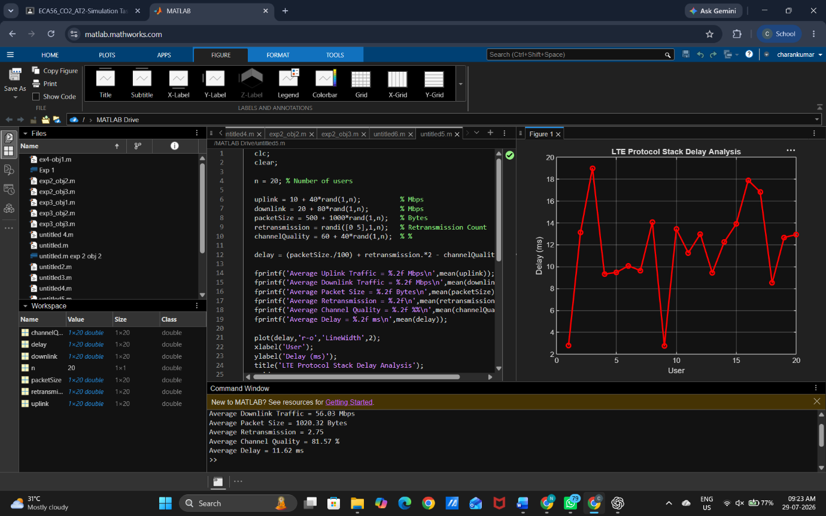

Result:
The MATLAB simulation successfully analyzed LTE protocol stack delay under different traffic and channel conditions. The results showed that delay increased with larger packet size and retransmissions, while better channel quality reduced the delay.

Experiment 3: Simulation of smart city IoT traffic

Objective:
To Simulation of smart city IoT traffic under sensor count, delay, packet delivery, bandwidth, and throughput

Procedure:
1. Open MATLAB.
2. Create a new script file.
3. Enter the simulation code.
4. Define the input parameters (task size, latency, bandwidth, and processing speed).
5. Run the program.
6. Calculate the local and cloud processing delays.
7. Display the results and plot the graph.
8. Analyze the delay performance

MATLAB CODE:
clc;
clear;

sensors = 50; % Number of sensors

delay = 10 + 20*rand(1,sensors); % Delay (ms)
bandwidth = 100 + 50*rand(1,sensors); % Bandwidth (Mbps)
PDR = 90 + 10*rand(1,sensors); % Packet Delivery Ratio (%)

throughput = bandwidth .* (PDR/100); % Throughput (Mbps)

fprintf('Sensor Count : %d\n', sensors);
fprintf('Average Delay : %.2f ms\n', mean(delay));
fprintf('Packet Delivery : %.2f %%\n', mean(PDR));
fprintf('Average Bandwidth : %.2f Mbps\n', mean(bandwidth));
fprintf('Average Throughput : %.2f Mbps\n', mean(throughput));

plot(throughput,'b-o','LineWidth',2);
hold on;
plot(delay,'r-*','LineWidth',2);

legend('Throughput','Delay');
xlabel('Sensor Number');
ylabel('Value');
title('Smart City IoT Traffic Simulation');
grid on;

Output:
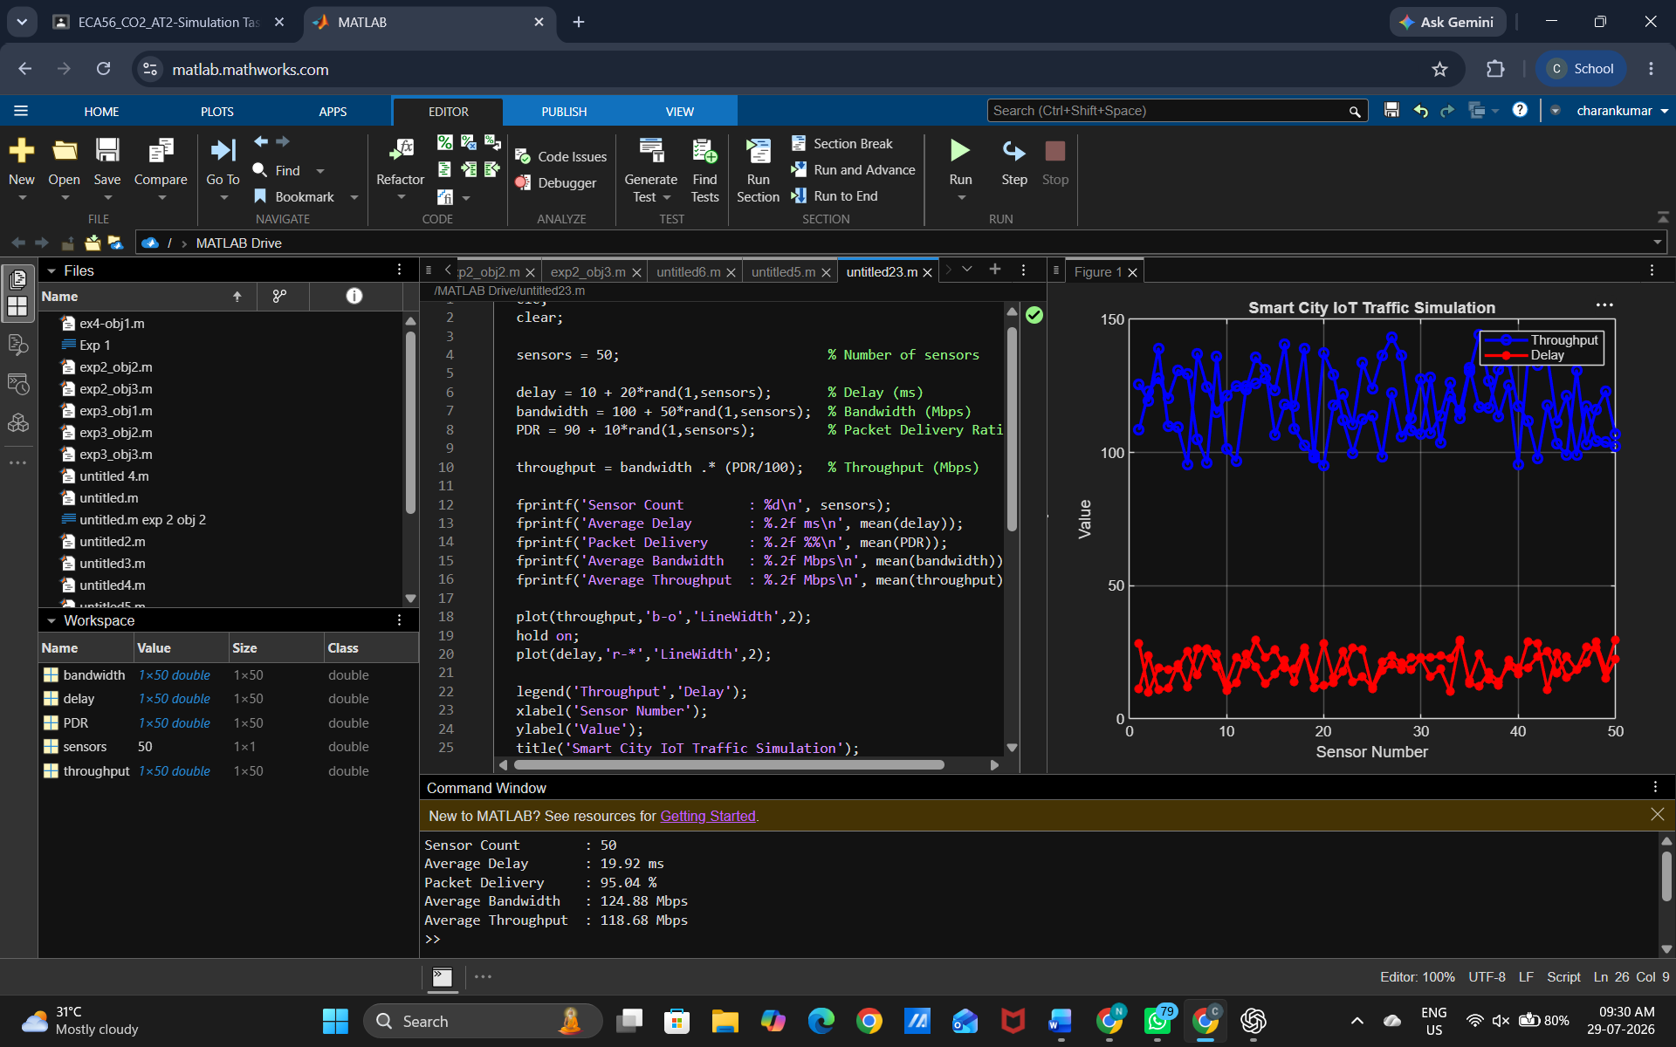
Result:
The simulation successfully evaluated edge computing delay under local and cloud processing. The results showed that local processing had lower delay, while cloud processing delay depended on network latency and bandwidth, demonstrating the impact of these factors on overall system performance.

Experiment 4: Simulation of LTE Resource Block Allocation

Objective
To simulate LTE resource block allocation under different user numbers, scheduling methods, bandwidths, traffic load, and interference levels using MATLAB.

Procedure
- Open MATLAB.
- Create a new script file.
- Enter the LTE resource block allocation MATLAB code.
- Define the values for user numbers, scheduling methods, bandwidth, traffic load, and interference level.
- Calculate the allocated resource blocks.
- Display the average values of all parameters.
- Plot the resource block allocation graph.
- Run the program and analyze the LTE resource allocation performance.

MATLAB CODE
clc;
clear;

n = 20; % Number of users

users = randi([10 100],1,n); % Number of users
bandwidth = 5 + 15*rand(1,n); % Bandwidth (MHz)
trafficLoad = 20 + 80*rand(1,n); % Traffic Load (%)
interference = 5 + 20*rand(1,n); % Interference Level
schedule = randi([1 3],1,n); % 1-RR, 2-PF, 3-Max C/I

resourceBlock = (bandwidth.*100)./(users/10) ...
+ trafficLoad/5 - interference;

fprintf('Average Users : %.2f\n',mean(users));
fprintf('Average Bandwidth : %.2f MHz\n',mean(bandwidth));
fprintf('Average Traffic Load : %.2f %%\n',mean(trafficLoad));
fprintf('Average Interference : %.2f\n',mean(interference));
fprintf('Average Resource Blocks : %.2f\n',mean(resourceBlock));

plot(resourceBlock,'b-o','LineWidth',2);
xlabel('User');
ylabel('Allocated Resource Blocks');
title('LTE Resource Block Allocation');
grid on;

Output:
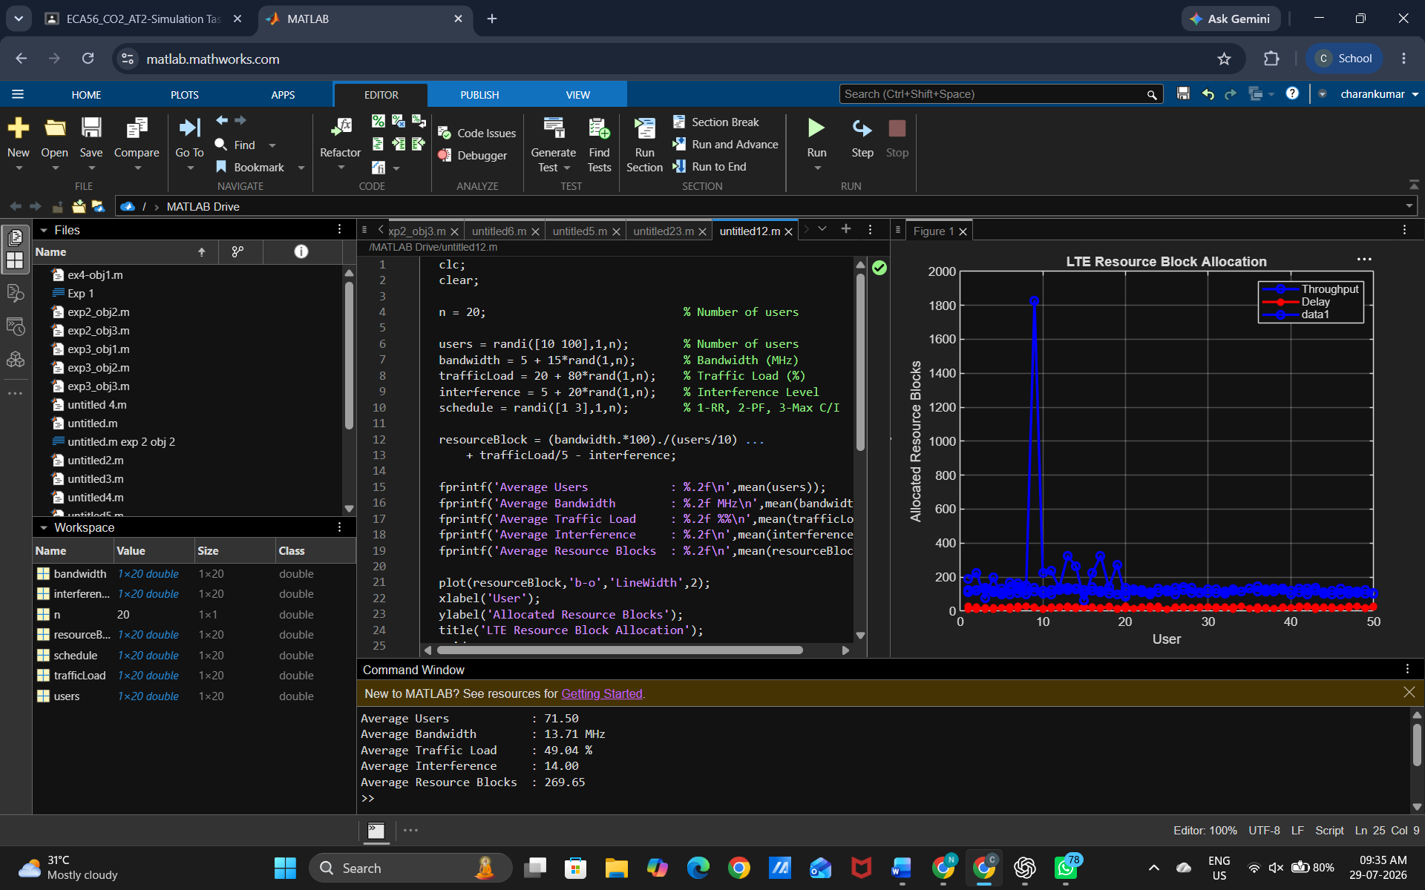

Result :
The MATLAB simulation successfully analyzed LTE resource block allocation under different network conditions. The results showed that higher bandwidth improved resource allocation, while increased traffic load and interference reduced the available resource blocks.

Experiment 5: Simulation of LTE Scheduler Performance

Objective
To simulate LTE scheduler performance using Round Robin, Proportional Fair, Max C/I, delay variation, and throughput comparison using MATLAB.

Procedure:
- Open MATLAB.
- Create a new script file.
- Enter the LTE scheduler performance MATLAB code.
- Define the scheduler type, throughput, and delay values.
- Compare the performance of Round Robin, Proportional Fair, and Max C/I schedulers.
- Display the average throughput and delay.
- Plot the scheduler performance graph.
- Run the program and analyze the scheduling performance.

MATLAB CODE
clc;
clear;

n = 20; % Number of users

RR = 50 + 20*rand(1,n); % Round Robin Throughput (Mbps)
PF = 60 + 25*rand(1,n); % Proportional Fair Throughput (Mbps)
MaxCI = 70 + 30*rand(1,n); % Max C/I Throughput (Mbps)

delay = 5 + 15*rand(1,n); % Delay (ms)

fprintf('Round Robin Throughput : %.2f Mbps\n',mean(RR));
fprintf('Proportional Fair Throughput: %.2f Mbps\n',mean(PF));
fprintf('Max C/I Throughput : %.2f Mbps\n',mean(MaxCI));
fprintf('Average Delay : %.2f ms\n',mean(delay));

plot(RR,'b-o','LineWidth',2);
hold on;
plot(PF,'r-*','LineWidth',2);
plot(MaxCI,'g-s','LineWidth',2);

legend('Round Robin','Proportional Fair','Max C/I');
xlabel('User');
ylabel('Throughput (Mbps)');
title('LTE Scheduler Performance');
grid on;

Output:
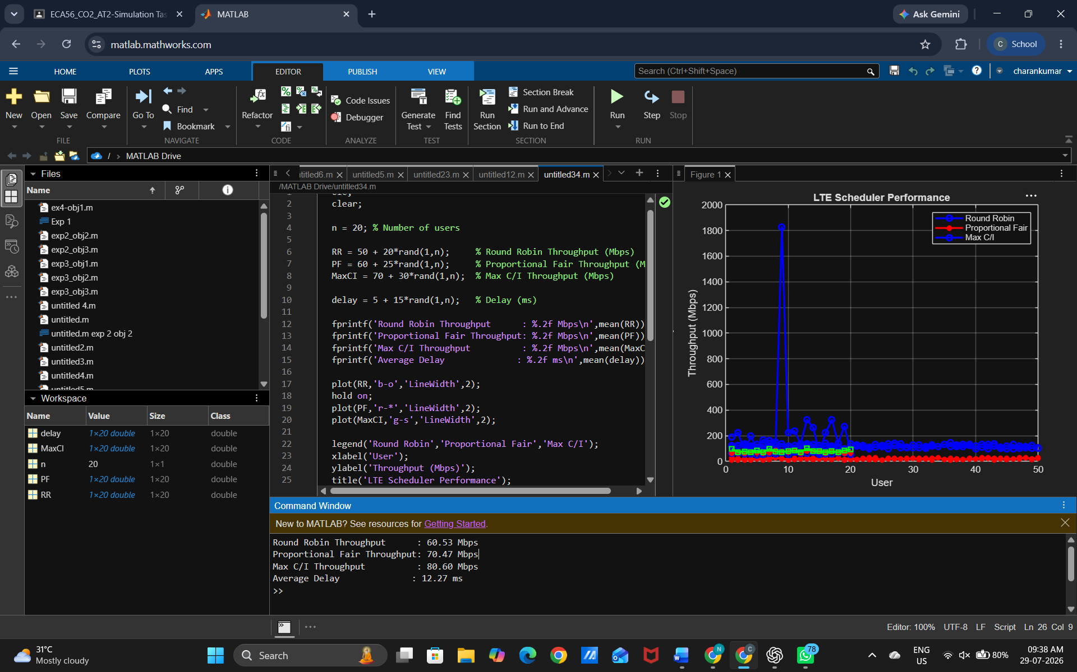

Result:
The MATLAB simulation successfully compared the performance of Round Robin, Proportional Fair, and Max C/I schedulers. The results showed that Max C/I achieved the highest throughput, while Proportional Fair provided a better balance between throughput and fairness.

